

**Sukkur IBA University**

**Department of Computer Science**

Applied Physics, Spring 2024

**Lab-01**

**Introduction to NI Elvis KIT and NI Multisim**

**Lab Instructor: Engr. Asif Ali**

**Submission Profile**

Name: Submission Date:

Enrolment ID: Receiving Authority Name and Signature:

Comments: ______________________________________________________________________

Instructor Signature

**Objectives:**

* **To be Familiarize with NI-ELVIS II KIT, Software, and basics of applied physics.**

**Introduction:**

The NI Engineering Laboratory Virtual Instrumentation Suite (NI ELVIS) II is a modular engineering educational laboratory device developed specifically for academia. With its hands-on approach, educators can help students to learn practicals, experimental skills. NI ELVIS II features one compact form factor integrated with 12 of the most commonly used instruments in the laboratory, including an oscilloscope, digital multimeter, function generator, variable power supply, and Bode analyzer. You can connect the PC to these various measurements through USB plug‑and‑play capabilities and build circuits on a detachable prototyping board.

**NI-ELVIS Series II**

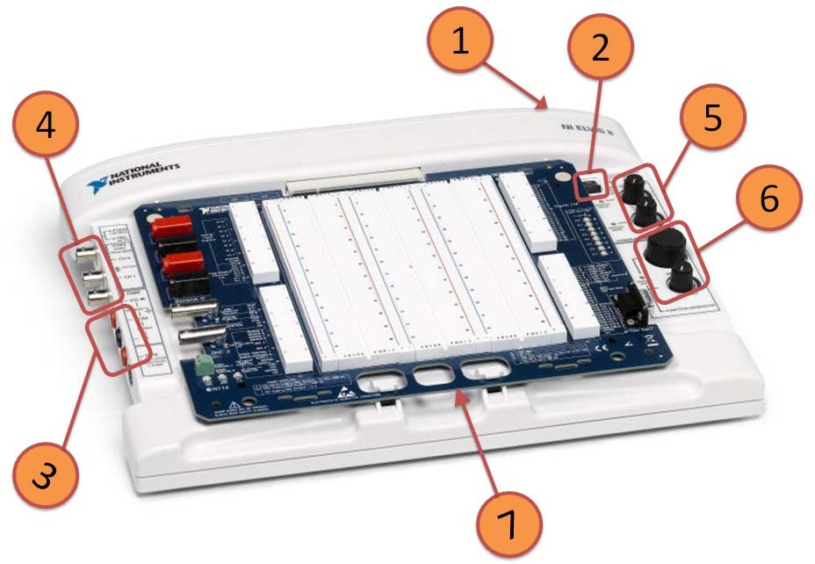The major device that you will use in this lab is the NI ELVIS Series II workstation shown in Figure 1. The workstation consists of a prototyping board and several other features that are essential for laboratory experiments conducted in the CSE department. These features are explained below in Table 1

*Figure 1. Isometric View of NI ELVIS II workstation with Prototyping Board*

*TABLE I. WORKSTATION FEATURES*

# Workstation Power Switch

* **Located in the rear of the workstation.**

# Powers the NI ELVIS II series

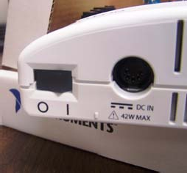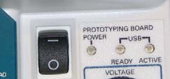

**Prototyping Board Power Switch**

* Controls power to *NI ELVIS Series II* prototyping board.
* The power LED lights up when the switch is turned ON.
* The Ready switch should be green or yellow when connected to host.

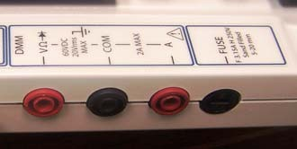

# Digital Multimeter (DMM) Connectors

* ***Voltage, Resistance, and Diode Banana Jack (red):*** The positive input for digital multimeter in voltage resistance and diode measurements.
* ***Common Banana Jack (black):*** The common reference connection for digital multimeter voltage, current, resistance, and diode measurements.
* ***Current Banana Jack (red):*** The positive input for digital multimeter current measurements.

# Oscilloscope Connectors and Function Generator Outputs/Digital Trigger Input

## Oscilloscope (Scope) Connectors (Input)

* ***CH 0 BNC Connector:*** The input for channel 0 of the oscilloscope.

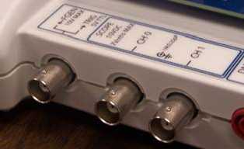

* ***CH 1 BNC Connector:*** The input for channel 1 of the oscilloscope.

## FGEN/Trigger Connector

Optional output of the function generator or a digital trigger input.

# Variable Power Supply Manual Controls

This allows you to adjust the voltage for two variable power supplies.

* + ***Supply+*** which can supply between 0 and +12V

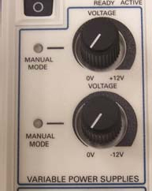

* + ***Supply–*** can which supply between 0 and -12V
  + Knobs active only when the associated power supply is in manual mode.
  + LED lights up next to each knob lights up when associated power supply is in manual mode.

# Function Generator Manual Control

These knobs allow the user to manually adjust the frequency and amplitude for a function generator output waveform. The *Manual Mode* LED lights up when the function generator is in manual mode.

Instructions on how to use the function generator to input a waveform and to adjust its frequency and amplitude are explained later.

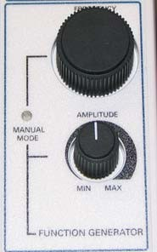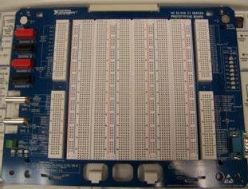

# NI ELVIS II Series Prototyping Board

Provides an area for building circuitry and has necessary connections to access signals for common applications

***PROTOTYPING BOARD FEATURES***

The prototyping board has several features on interest that are labeled in Figure 2. ***Each signal in features 2, 3, 6 and 8 has a row of five pin sockets all tied together.***

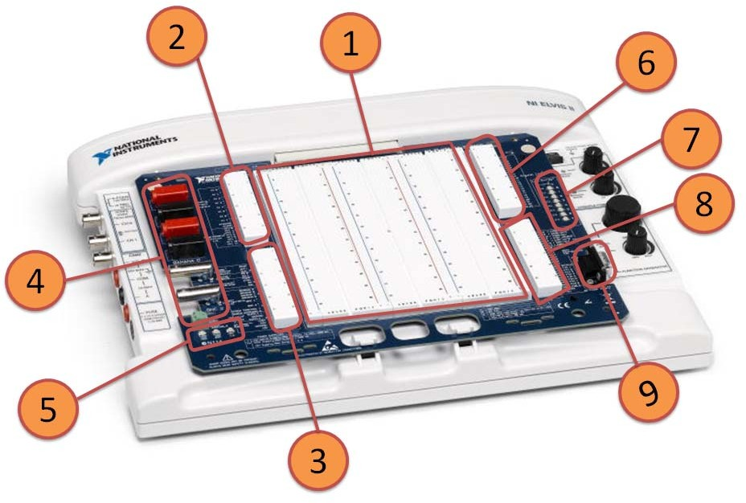

*Figure 2. NI ELVIS II Series Prototyping Board*

*TABLE II. SIGNAL DESCRIPTIONS ON NI ELVIS II PROTOTYPING BOARD*.

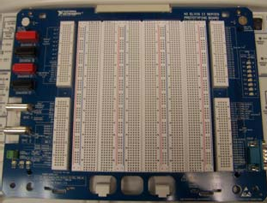

–

–

–

Breadboard

This is the work area on which circuits are built. Figure 3 shows how the terminals are internally connected.

The horizontal connections labeled “+” and “-” and colored red and blue are called buses and are typically used for power and ground signals.

– The vertical contacts are used for the actual building of circuits

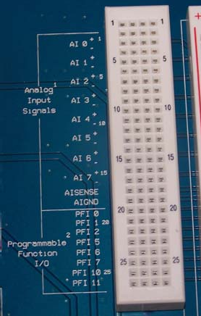

Analog Input (AI) and Programmable Functions Interface (PFI) signal rows

# Analog Inputs

There are 8 analog input channels labeled AI<0…7>±. Connect positive end of the signal to be measured to the positive “+” pin socket and the negative end of the signal to the negative “-” pin socket of the input channel. These channels are mostly used as inputs for the oscilloscope discussed later.

# Programmable Functions I/O

* These lines labeled <0…2>, <5…7> and <10…11> are used for static digital input output or timing signals.

# AI SENSE and AI GND (INPUT): These pin sockets are used in cases where the signal to be measured has a different ground potential from workstation.

Digital Multimeter (DMM)/ Impedance Analyzer

# DMM/Impedance Analyzer (INPUT)

* + **BASE:** excitation terminal used as base terminal in 3- wire voltage/current analyzer of a bipolar junction transistor discussed later.
  + **DUT+:** excitation for capacitance and inductance measurements, impedance analyzer, 2-wire voltage/current analyzer and collector terminal for a bipolar junction transistor for 3-wire voltage/current analyzer. All of which are discussed later.
  + **DUT-:** virtual ground for capacitance and inductance measurements, impedance analyzer, 2-wire voltage/current analyzer and emitter terminal for a bipolar junction transistor for 3-wire voltage/current analyzer.

Analog Output (AO)

# Analog Outputs

There are 2 analog output channels labeled AO<0…1>±. These channels are used as outputs for the arbitrary waveform generator discussed later.

User Configurable Input/Output

# User Configurable I/O

* + - BANANA <A…D>: Connects to the banana jacks A- D (see feature 4).
    - BNC <1…2>±: Positive lines connect to center pins of the BNC connectors (see feature 4). Negative lines connect to shells of the BNC connectors.
    - SCREW TERMINAL <1…2>: connects to the screw terminals (see feature 4).

Function Generator (FGEN)

# Function Generator

* + - FGEN (Output): the output of the function generator
    - SYNC (Output): 5V TTL signal synchronized to the FGEN signal. This signal is most used as a trigger signal for the oscilloscope (see feature 4 in Table 1).
    - AM (Input): Analog input used to modulate the amplitude of the FGEN signal.
    - FM (Input): Analog input used to modulate the frequency of FGEN signal.

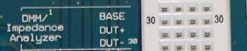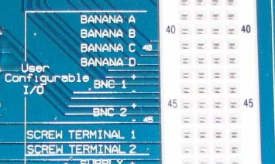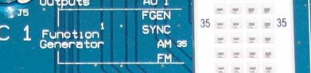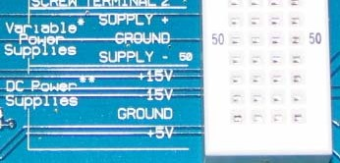

Power Supplies

# Variable Power Supplies (OUTPUT)

* + - * SUPPLY+: Positive variable power supply output (see feature 5 in Table 1). Can supply between 0 and

+12V.

* + - * GROUND: Ground (all signals referenced to ground).
      * SUPPLY-: Negative variable power supply output (see feature 5 in Table 1). Can supply between 0 and - 12V.

# DC Power Supplies (OUTPUT)

– +15V fixed power supply.

* -15V fixed power supply.
* GROUND: Ground.

– +5V fixed power supply

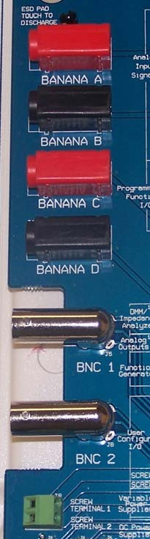

–

User-Configurable Screw Terminals, BNC connectors and Banana jack connectors

–

–

**Banana <A…D> Jacks**: connected to BANANA

<A…D> signal rows (see feature 3).

**BNC <1…2> Connectors**: connected to BNC

<1…2>± signal rows (see feature 3).

**SCREW TERMINAL** <1…2>: connects to the screw terminal signal rows (see feature 3).

DC power supply indicators

* + - ±15V and +5V power supply indicators: These indicators should be lit to when the prototyping board power is enabled.
    - If these indicators are not lit, then there is a possible short circuit. Turn off prototyping board and check connections.

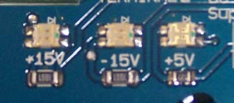

* + - Turning the board power switch on and off should reset the current limiters.

Digital input/output signal rows

# DIO <0…23> (INPUT/OUTPUT)

Digital I/O lines that are used to read or write digital data (0 or 5V). These lines are programmed to be inputs or outputs using soft front panels (SFPs) discussed later.

User-Configurable LEDs

# User-Configurable LEDs (OUTPUT)

These LEDs act as displays for digital outputs (i.e. 0 or 5V). See feature 8 for further insight.

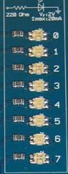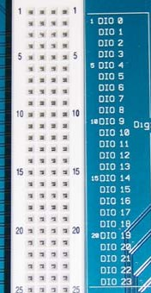

Counter/Timer User-Configurable Input/Output

DC Power Supply

# Counter/Timer (INPUT/OUTPUT)

* + - PFI8/CTRO_SOURCE: Counter 0 Source

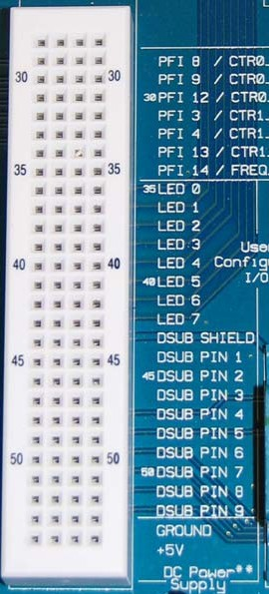

* + - PFI9/CTRO_GATE: Counter 0 Gate
    - PFI12/CTRO_OUT: Counter 0 Out
    - PFI3/CTR1_SOURCE: Counter 1 Source
    - PFI4/CTR1_GATE: Counter 1 Gate
    - PFI13/CTR1_OUT: Counter 1 Out
    - PFI14/FREQ_OUT: Frequency Out

# LED<0…7> (INPUT)

* + - Input pin sockets for user-configurable LEDs (see feature 7).

# DSUB SHIELD (INPUT/OUTPUT)

* + - Connects to shield of DSUB connector (see feature 9).

# DSUB PIN<1…9> (INPUT/OUTPUT)

* + - Connects to pins <1…9> of DSUB connector (see feature 9).

# DC Power Supply (OUTPUT)

* + - Ground

– +5V fixed power supply

|  |  |  |
| --- | --- | --- |
| User-Configurable DSUB connector |  | **DSUB Connector (I/O)**  Connected to DSUB PIN <1…9> and DSUB SHIELD signal rows (see feature 8). |

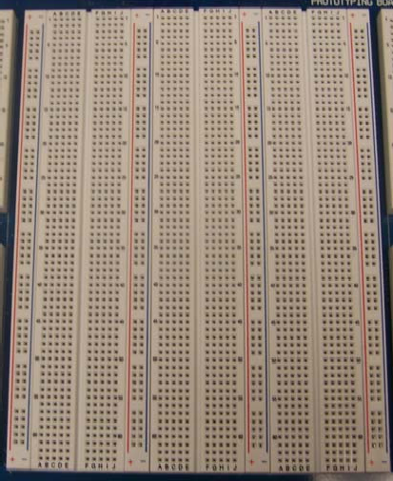

Each of these five sets of contacts are tied together

All pins on each of these columns are connected together. So the user can use “+” for DC power supply and “-” for ground

*Figure 3. Breadboard connections*

**NI ELVIS II DEVICES**

It provides an overview of the devices present in the NI ELVIS II Series workstation. These devices can be controlled by software to include soft front panel (SFP) instruments, Lab VIEW Express VIs, and Signal Express blocks. For the purposes of the CSE department, the use of NI ELVIS II Series with SFP instruments will be discussed exclusively. A NI ELVISmx SFP, as the name implies, is the software version of the front panel of an NI ELVIS device.

1. ***NI ELVISmx Instrument Launcher:***

The NI ELNIS Instrument Launcher provides access to the NI ELVISmx SFP instruments. Launch the Instrument Launcher by navigating to Start>>All Program Files>>National Instruments>>NI

ELVISmx>>NI ELVISmx Instrument Launcher. This opens the GUI shown in Figure 4. To launch an instrument, click the button corresponding to the desired instrument. Before opening a SFP, the workstation should be powered with the USB READY light lit, otherwise an error occurs. If said error occurs, close SFP, power on the workstation, check connection to host PC, and open SFP again.

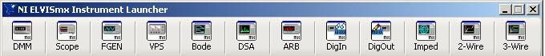

*Figure 4. NI ELVISmx Instrument Launcher*

1. ***DMM (Digital Multimeter)***

This commonly used instrument is used to measure voltage (DC and AC), current (DC and AC), resistance, capacitance, inductance. Additionally, it used for diode tests and audible continuity tests. The DMM SFP is shown in Figure 5.

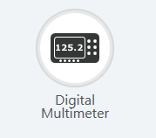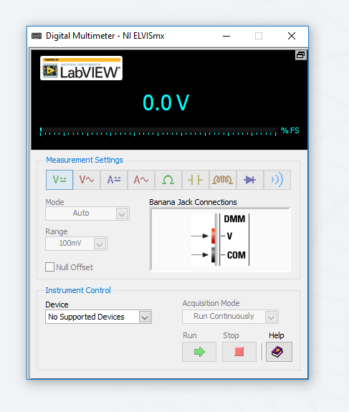

F*igure 5. DMM SFP*

1. ***Scope (Oscilloscope)***

The oscilloscope is a device that displays signal voltages as a two-dimensional graph of electrical potential differences (vertical axis) plotted as a function of time (horizontal axis). Though time-invariant (DC) voltages can be displayed, this device is commonly used to display time-varying voltage signals. The NI ELVISmx Oscilloscope consists of two channels, Channel 0 and Channel 1, which can automatically connect to up to ten (10) sources. Shown below is the Scope SFP in Figure 6,

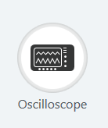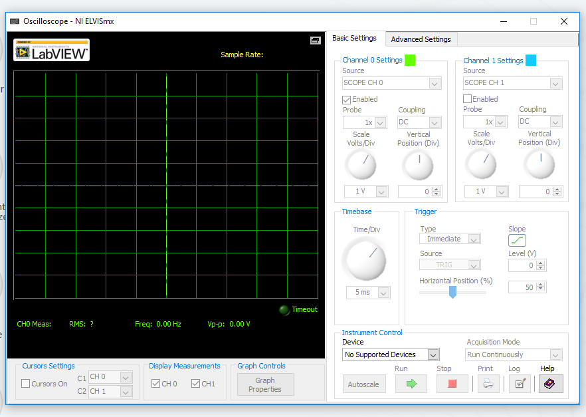

*Figure 6. DMM SFP*

1. ***FGEN (Function Generator)***

The function generator is a device that generates time varying waveforms. The NI ELVISmx Function generator is generally used to generate a periodic voltage signal in the form of a sine wave, a triangular wave or a square wave. The function generator output can be obtained via two routes: the FGEN BNC output channel (see feature 4 in Table 1) or the FGEN prototyping board pin sockets (see feature 3 in Table 2). Shown below is the FGEN SFP in Figure 7.,

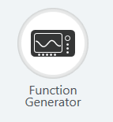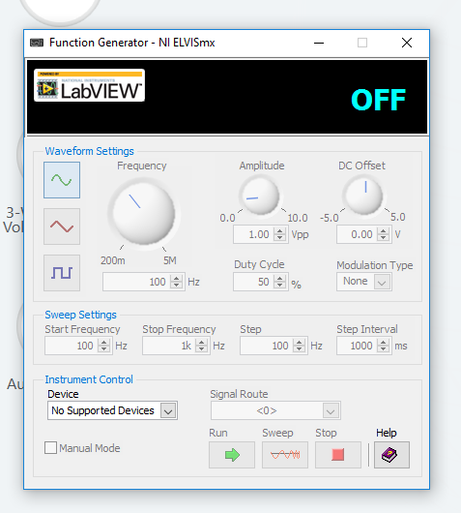

*Figure 7. FGEN SFP*

1. ***VPS (Variable Power Supply)***

The variable power supply consists of two channels that supply adjustable output voltages from 0 to +12V on the SUPPLY+ channel and 0 to -12V on the SUPPLY- channel. The SUPPLY+ and SUPPLY- channels are available as prototyping board signal rows (see feature 3 in Table 2). The output voltages are referenced to GROUND. Shown below is the VPS SFP in Figure 8.

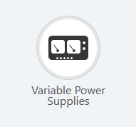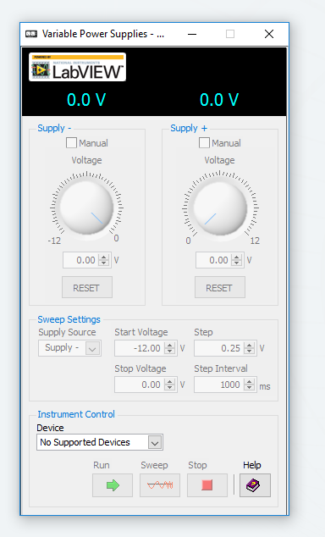

*Figure 8. VPS SFP*

1. ***Bode (Bode Analyzer)***

A bode analyzer describes the frequency response of a circuit-under-test (e.g. a low pass RC filter) by displaying the Gain (in dB) and Phase (degrees) of the circuit-under-test as a function of frequency. The NI ELVISmx Bode analyzer uses the Function generator to output a stimulus and then uses two input channels to measure the circuit response and stimulus and computes the Gain (in dB) and Phase (degrees) of the system under test based on the measured signals. Shown below is the Bode SFP in Figure 9.

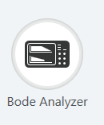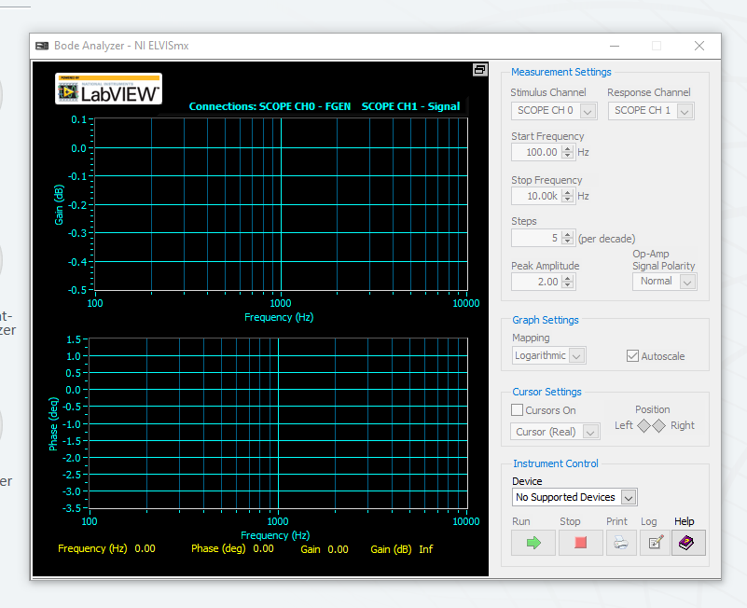

*Figure 9. Bode SFP*

1. ***DSA (Dynamic Signal Analyzer)***

The dynamic signal analyzer is an instrument performs a frequency domain transform of a signal.

The NI ELVISmx Dynamic Signal Analyzer consists of a single channel, which can automatically

connect to up to ten (10) sources. It can continuously make measurements or take a signal scan.

Shown below is the DSA SFP in Figure 10.

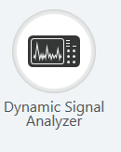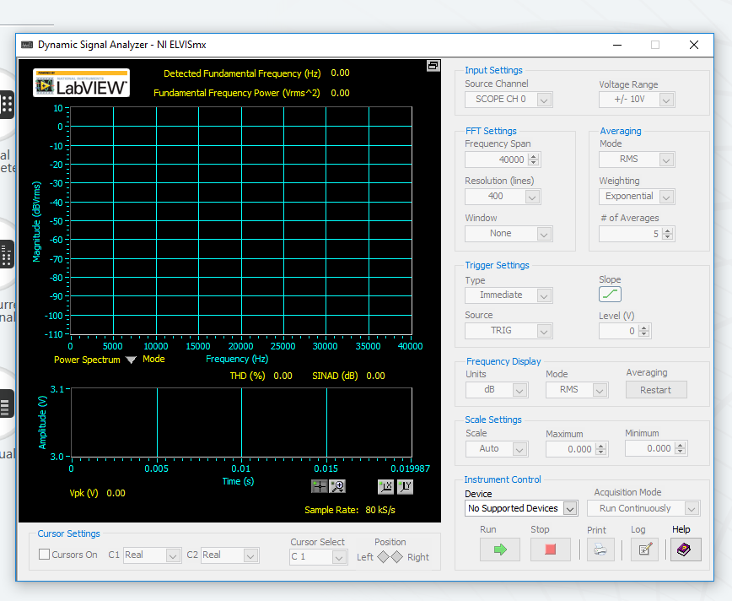

*Figure 10. DSA SFP*

1. ***ARB (Arbitrary Waveform Generator)***

The arbitrary waveform generator allows the user to create a variety of signal voltage types using the Wave form Editor software and output the created signals via the analog output channels AO <0…1> (see feature 3 in Table 2). The presence of two output channels allows for the simultaneous generation of two waveforms. Shown below is the ARB SFP in Figure 11.

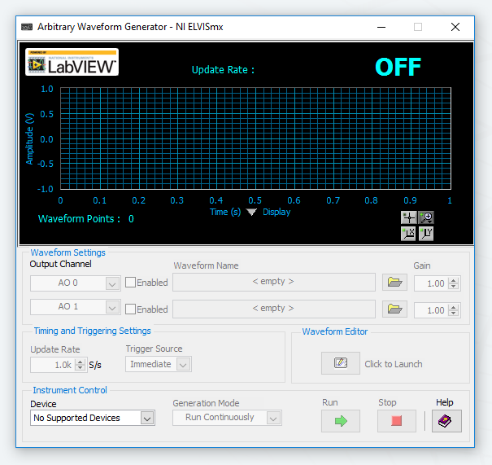

*Figure 11. AWG SFP*

1. 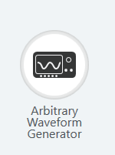***DigIn (Digital Reader)***

The NI ELVISmx II Digital Reader SFP allows the user to read digital data from eight consecutive lines at a time. This instrument is a software (virtual) form of the user configurable LEDS shown in feature 7 in Table 2. The eight consecutive lines could be either the DIO<0…7>, DIO <8…15>, or DIO<16…23> signal rows (see feature 6 in Table 2). Shown below is the DigIn SFP in Figure 12.

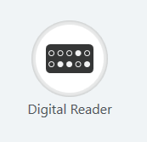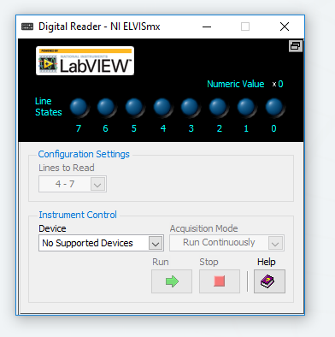

*Figure 12. DigIn SFP*

1. ***Imped (Impedance Analyzer)***

The Impedance Analyzer is a device capable of measuring the resistance and reactance of a passive two-wire element at a given frequency. The device is commonly used as an aid to explain sinusoidal steady state analysis (i.e. used to compute amplitude and phase changes of sinusoidal alternating current going through a passive two-wire element). To measure the test circuit, the two wires of the element are connected to DUT+ and DUT- signal rows of the NI ELVISmx prototyping board (see feature 3 in Table 2). Shown below is the Imped SFP in Figure 13.

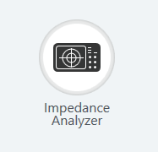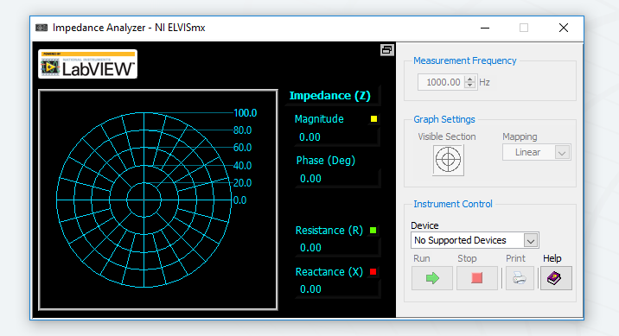

*Figure 13. Imped SFP*

Exercise

Answer the following questions

Q01: Write down the importance of Applied Physics in daily life. Answer should be short and concise.

Q02: Why color coding is used in resistors?

Q03: If the voltage and resistors are increased in any circuit then current will be increased? Yes or NO. If yes then why? If no then why?

Task-01: Design the following circuits on Multisim

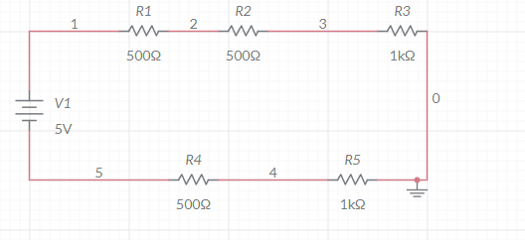

Task-02: Design the following circuits on Multisim

